
Project Title- HEALTH AND MOVEMENT MONITORING SYSTEM FOR SOLDIERS
Paper Code-KEC-753
Semester: VII
in
I.T.S Engineering College Gr. Noida

Submitted for partial fulfilment of award of

BACHELOR OF TECHNOLOGY
Degree in

Electronics & Communications Engineering

1st Report Submitted by

S. NO | STUDENT NAME | STUDENT ROLL NO. | MOBILE NO.
01. | AMBIKA | 2002220310004 | 7289892862
02. | RAHUL RAJ | 2002220310016 | 7283083763
03. | RAJU KUMAR | 2002220310017 | 7562838529

Under the Guidance of
(Asst. Prof. Mr. Agha A. Hussain )

DEPARTMENT OF ELECTRONICS & COMMUNICATION ENGINEERING

I.T.S ENGINEERING COLLEGE, Gr. Noida

46, KNOWLEDGE PARK-III, GREATER NOIDA



Affiliated from Dr. A.P.J Abdul Kalam Technical University, Lucknow
Session 2020-2024

INTRODUCTIONS

In today’s world, warfare is an important factor in any nation’s security. One of the important and vital roles is played by the army soldiers. There are many concerns regarding the safety of soldiers. So far their security purpose, many instruments are mounted on them to view their health status as well as their real time location. Bio-sensor systems comprise various types of small physiological sensors, transmission modules and processing capabilities, and can thus facilitate low-cost wearable unobtrusive solutions for health problem monitoring.

Traditional methods of health monitoring often fall short in providing real-time insights into the physiological and psychological conditions of military personnel. To address this challenge, the integration of Smart Health Monitoring Systems (SHMS) has emerged as a transformative approach, leveraging cutting-edge technologies to enhance the healthcare support for soldiers.

Smart Health Monitoring Systems, powered by Machine Learning (ML) algorithms, have shown promising results in revolutionizing the way we monitor, analyse, and respond to the health needs of military personnel. These systems not only offer continuous, non-intrusive monitoring but also possess the capability to predict and prevent potential health issues, thereby improving the overall readiness and effectiveness of the armed forces.

This comprehensive review aims to explore the latest developments in smart health monitoring technologies tailored specifically for soldiers. We delve into the integration of ML algorithms in monitoring various physiological parameters such as heart rate, body temperature, sleep patterns, and stress levels, real time location and movement tracking. Furthermore, we analyse the incorporation of advanced sensor technologies, wearable devices, and Internet of Things (IoT) solutions that form the backbone of these systems, providing a holistic and real-time picture of the soldier's health status.

The paper also addresses the challenges and ethical considerations associated with implementing smart health monitoring systems in military contexts. Privacy concerns, data security, and the seamless integration of these technologies into the existing military infrastructure are critical aspects that demand thorough exploration.

As we embark on this review journey, it becomes evident that the synergy between smart health monitoring systems and machine learning holds immense potential to revolutionize military healthcare. By enhancing the early detection of health issues, optimizing treatment strategies, and promoting proactive wellness, these systems contribute significantly to the overarching goal of ensuring the health and resilience of our armed forces.

In the subsequent sections, we delve into the key components of smart health monitoring systems, the machine learning algorithms driving their functionalities, and the potential impact on military operations. Through this exploration, we aim to provide a comprehensive understanding of the current state-of-the-art, challenges, and future prospects in the realm of smart health monitoring for soldiers.

This system helps to monitor health parameters of soldier, track their position, detect nearby bombs and predict the warzone environment using various sensors and K-Means machine learning algorithm.

The system helps the soldier to get help from army control unit and/or from another fellow soldier in panic situation. It will prove to be very useful to military forces during war and rescue operations as it can be used without any network restriction combining the capabilities of ZigBee and LoRaWAN.

Thus, this system provides security and safety to our soldiers. The proposed work can be expanded in the future in many directions.
The problem under study consists of improvement in health care system using cloud. We passionately dedicated to help medical fraternity to find health status of vital organs of the patient's body at early stage that support effective treatment by introducing innovative and high quality hand carried non-invasive health care systems and devices.

Cloud based Health Care is the integration of cloud computing and health monitoring. The computing device enables the delivery of accurate medical information anytime anywhere by means of internet. Cloud based healthcare system consists of a computing device and number of sensors mounted on patient's body.

In this paper we present a Cloud based Intelligent Healthcare Monitoring System (CIHMS).

In general IoT based health care platform which connects with smart sensors attach with human body for health monitoring for daily check-up. In project work we discussed about IoT based integrated patient health monitoring system.

The system technologies being used by smart phones or gadgets in present time where we also mentioned about advantages, challenges and opportunities. Due to the importance of observing medical patient, continuous remote monitoring is necessary. Our project work is giving the opportunity to monitor patient continuously by using the web and apps service along with live monitor and mobile message service. This paper also compared the early aged medical system between present time health monitoring.

The present time represents the time reducing; reduce health care cost especially for rural area people. The subsequent development of the project is extremely crucial in order to make the system more advanced and useful. In the designed system the improvement or amplification would be linking more sensors to internet which assess various other health parameters and would be advantageous for patient monitoring i.e. linking all the sensors to internet for swift and effortless access to establish a Wi-Fi mesh type network to increase in the Communication range.

Think Speak has been proposed to be used as the IoT-based Cloud Platform for the prototype model. It offers free data storage and analysis of time-stamped numeric or alphanumeric data.

Thing Speak library enables an Arduino or other compatible hardware to write or read data to or from Thing Speak. It is an open data platform for the Internet of Things (IoT) with MATLAB analytics and data visualization. It enables sensors, instruments, and websites to send data to the cloud where it is stored in either a private or a public channel.

Data is stored in private channels by default, but public channels can be used to share data with others. Once our data is collected or uploaded in a Thing Speak channel, it can be analysed, visualized and shared on social media, web services, and other devices.

LITERATURE SURVEY

Sashay Gondola et al. (2020) have extensively explored the realm of wearable sensors designed for monitoring human physiological parameters. These sensors, characterized by their wear ability, portability, and compact size, have been developed to track various aspects of human health. The body Sensor Network (BSN) emerges as a pivotal technology in this context, incorporating a diverse range of biomedical and physiological sensors. Noteworthy examples include blood pressure sensors, electrocardiogram (ECG) sensors, and electro dermal activity (EDA) sensors, strategically positioned on the human body to facilitate real-time health monitoring.

Animesh Sengupta et al.(2019) A system has been proposed to provide the capability to track soldiers at any given moment. Soldiers gain the ability to communicate with a control unit by sharing GPS coordinate information in times of distress. This system facilitates the real-time transmission of sensed and processed parameters of soldiers, allowing the army control unit to monitor crucial health metrics such as heartbeat and body temperature through the use of Body Sensor Networks. The wireless transmission of soldiers' parameters is achieved through GSM technology.

Versin et al. (2021) studied and found that the LoRaWAN network infrastructure can cover an average area of approximately 33 km² when the LoRaWAN Gateway is positioned outdoors at a 12-meter altitude. Notably, the power consumption of this health monitoring system is claimed to be at least ten times lower than other long-range cellular solutions, such as GPRS/3G/4G. This suggests that the proposed LoRaWAN-based system presents a more energy-efficient alternative for health monitoring, particularly in areas with limited cellular network coverage.

Dhruv dixit et al. (2019) employed GPS, a Heart rate sensor, a Temperature Sensor, a Vibration sensor, a Bomb Detector, and a PIC16F877A Microcontroller for the prototype. The heartbeat sensor in this project utilizes a polar heart rate transmitter and RMC01 receiver. Additionally, the paper suggests the incorporation of a piezo disk vibration sensor, employing piezo-electric plate technology, known for its lightweight, flexibility, reliability, mobility, and cost-effectiveness compared to pricier sensors. To detect conditions such as Hypothermia and Hyperthermia,

Sarobin et al.(2018) Instead of using simple conditional statements, K-Means Clustering algorithm has been proposed. Clustering is a type of unsupervised learning that can be used to visualize similar kinds of data and cluster them together. Due to the unavailability of real time soldier data, clustering has been proposed initially. K-Means Classification can be easily applied on the real time data that will be collected eventually. The difference in sensor values will help us in clustering the data into clusters such as healthy, ill, abnormal and dead. Once the data has been collected and clustered, these clusters can be visualized for more instinctive summaries at the control unit.

Armoire et al. (2020) proposed a system of m-health that uses mobile devices to collect real-time data from patients in and store it on network servers connected to internet enabling access only to a certain specific clients. This data can be used for the medical diagnosis of patients and is achieved by using a number of wearable devices and body sensor network.

Tyagi et al. (2022) explored the role of IoT in healthcare and studied its technical aspects to make it reality and identify the opportunities for which they propose a cloud based conceptual framework in which the patients’ medical data and information can be securely transferred, with the permission of patient and their family by building a network among patient, hospital, doctors, Labs etc. The primary reason behind this is to relieve patient from the expensive clinical aid, overcome the shortage of doctors and therefore providing enhanced care and service to patients.

Vashitha et al. (2021) builds an IoT-aware healthcare monitoring system is introduced. A prototype is presented for the implementation of an IoT-aware healthcare monitoring system, which will reduce the cost of healthcare and will increase the need of specialized care. It alerts about the patient’s health condition in real-time, if any problem is experienced, and if the patient needs any medical attention or hospitalization.

Saini et al.( 2019) The paper proposes an approach where the health status of a patient is retrieved and delivers health-promoting messages in a non-interruptive fashion through a wireless body-area network; they can communicate with medical services. However, a multidisciplinary endeavour such as cloud is required to achieve their potentials for healthcare system that lead to the emergence of a new type of advanced service for healthcare. The proposed approach makes cloud based healthcare system more realistic and feasible in terms of providing expert-based medical care.

Kamble et al.( 2022) The deployment of mobile healthcare system is a complex procedure that involves the requirements for wireless and mobile networks, such as secure information exchange, reliable remote control, confidential data storage, effective mobility management, rapid emergency response, and continuous monitoring of a patient's medical conditions.

Asthana et al. ( 2021) studied the advancement in VLSI technology, the size of the sensors have been reduced which has led to the development of wearable solutions. Due to consistent internet connectivity, the devices are becoming more efficient and powerful. IoT based health monitoring devices monitor the sick individual 24/7. At any crucial situation, the devices bring about necessary signals by inspecting statistical data.
PURPOSED METHODOLOGY USED

1.Hardware Components with Specification

Arduino MEGA 2560

Heartbeat Sensor

Temperature Sensor and Humidity Sensor (DHT11)

Accelerometer (ADXL335)

Ethernet Shield (W5100)

GPS Module (NEO-6M)

ZigBee Module (XB Series 1)

Lora WAN Module

Bomb Detector (IED i.e. Improvised Explosive Device)

ECG Module (AD8232 i.e. Electro-Cardiogram)

2. Proposed Methodology

Real-time Data Sensing in the Warzone

Data collected from the war zone will be the indicator of soldier’s health condition. Insights such as nearby bomb detection can be made accordingly. Appropriate sensors are proposed for deployment so the data analytics performed using K-Means helps the control unit in mapping the conditions around the soldiers

.

Data Transmission

Data is transmitted from the soldier to the squadron leader using ZigBee. The squadron leader then collects this data and passes it to the control unit using LoRaWAN. Data can either be sent periodically after some fixed intervals or only when there is a significant change in the biomedical sensor readings of the soldier.

The hierarchy of obtaining data from the soldier is divided into three segments:

1. Soldier's Node - Level 1

2. Squadron's Node - Level 2

3. Control unit Node - Level 3
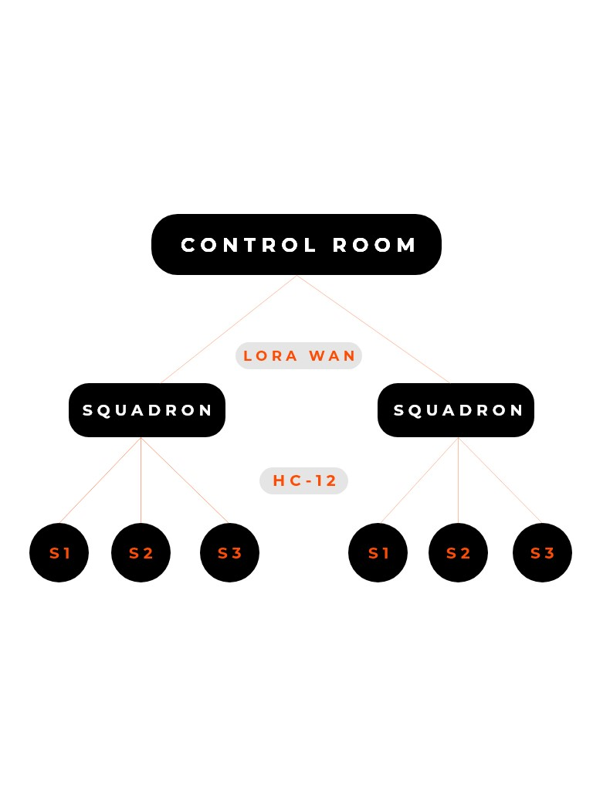
A breif explaination of all the nodes :

LEVEL 1. Soldier’s Unit

This unit consists of body area sensor networks such as temperature sensor, heart beat sensor, humidity sensor, vibration sensor, GPS and bomb detector. These sensors are used to sense the health parameters of soldiers, tracking their location and to detect if there has been a bomb explosion nearby by tracing explosive compounds in the environment. The sensed analog signals will be converted into digital signals using analog to digital converter and then compared with the normal conditional signals. If any discrepancy occurs between sensed signals and defined normal signals, then it will be considered as an emergency.The use of a paper bomb detector has also been proposed in this paper to detect the presence of any explosive compound in the atmosphere nearby. The soldier’s unit shall have a ZigBee module that will be used for communication between the soldier and the respective squadron leader.

LEVEL 2. The Squadron Leader’s Unit or Sub-Master’s Unit

For each and every field operation, there is always an on field Squadron Leader who is in continuous communication with the control unit. In the proposed methodology, this leader will be equipped with an extra Lora WAN module which will be responsible of transferring data through the LoRaWAN to the control unit. The sub-master unit will also be equipped with a ZigBee module to collect data from the other soldiers present in the area of operation. The sub-master unit and other soldier units would communicate using the multi-hop protocol. Thus, this sub-master unit acts as the cluster head for each and every squad that goes into the battle. free data storage and analysis of time-stamped numeric or alphanumeric.

LEVEL 3. Control Unit:

This node includes the wireless LoRa module, where it receives the data of both nodes i.e soldier’s and squadron leaders, from the squadron leader’s node. This node is just about monitoring, storing, and analyzing the received data from the other two node i.e Soldier’s node and the squadron leader’s node.

Additionally, the control unit node is provided with an extra feature, where they can monitor soldier’s directly through the internet using a graphical interface/dashboard. This is possible using the blynk application on the mobile phone available at control unit node, provided the soldier’s module is also connected to the internet.

6. Machine Learning Algorithm

From the sensor data collected on cloud like – temperature, humidity, heartbeat sensor insights will be derived using K-Means Clustering. It solves the problem of unsupervised learning as any information or an insight about the relations between different data that we are collecting is not available forehand. From the input data of different sensors, for different actions or events like running, walking, sitting, in case of bombing, injury; each cluster predicts these different events based on the data collected.

7. Proposed prototype

All the sensors such as Temperature sensor, Humidity sensor, Heart Beat Sensor, Accelerometer and GPS module along with either ZigBee Module or the LoRaWAN Module are integrated with the Arduino Mega 2560. Every soldier in the battlefield is provided with such model where various sensors’ real time data along with the soldiers’ location are sent to the squadron leader from the soldier using ZigBee module and the data received by the squadron leader is sent to the cloud through the LoRaWAN module as it supports long range communication and also fast communication. Data analytics using K-Means Clustering is applied on the collected data on the cloud to provide information about the soldier’s unit such as if they are bombed, injured or if they have died. The current war scenario along with the health of the soldiers deployed on the battle field can be viewed through the web portal and thus it would also help the headquarters in decision making.

The proposed work can be expanded in the future in many directions. Gyroscope and Accelerometer can also be used together for human activity recognition using machine learning. Blood pressure sensor and electro dermal activity sensor can also be implemented together to classify if the soldier is calm or is in distress. A suitable and better routing algorithm can be used to make this system more reliable and energy efficient. Ubiquitous computing will surround all the soldier’s environment that merges physical and computational infrastructures forming a whole new integration. It will feature a proliferation of hundreds or thousands of computing devices and sensors that will provide new functionality.

It Develop algorithms for real-time processing and analysis of health data and Ensure that the processing is efficient and timely, considering the limited resources of wearable devices .It Connect the smart health monitoring system with soldiers' electronic health records (EHRs) for comprehensive health management to Ensure compliance with healthcare data standards and regulations. Here it Design a user-friendly interface for soldiers and healthcare professionals to access and interpret health data. Implement real-time alerts and notifications for critical health events. It gives accessibility across various devices and platforms. Implement robust security protocols to protect sensitive health data during transmission and storage. It uses encryption, access controls, and authentication mechanisms to secure the Design the system to be scalable to accommodate a growing number of users and devices. Establish a maintenance plan to address updates, patches, and system enhancements. Ensure compliance with relevant healthcare and data protection regulations (e.g., HIPAA for the United States). Conduct regular audits to verify adherence to compliance standards. Provide comprehensive training for soldiers and healthcare personnel on using the smart health monitoring system. This methodology provides a structured approach to developing a smart health monitoring system for soldiers using cloud computing.

WORKING

The system has two sections, hardware and software. The system consists of 3 nodes i.e Soldier’s node, Squadron leader’s node, and Control unit node. At all the nodes Arduino constantly monitors and records data from the several sensors connected to the system, and communicates with other nodes using wireless modules present in the system.

Flow chart
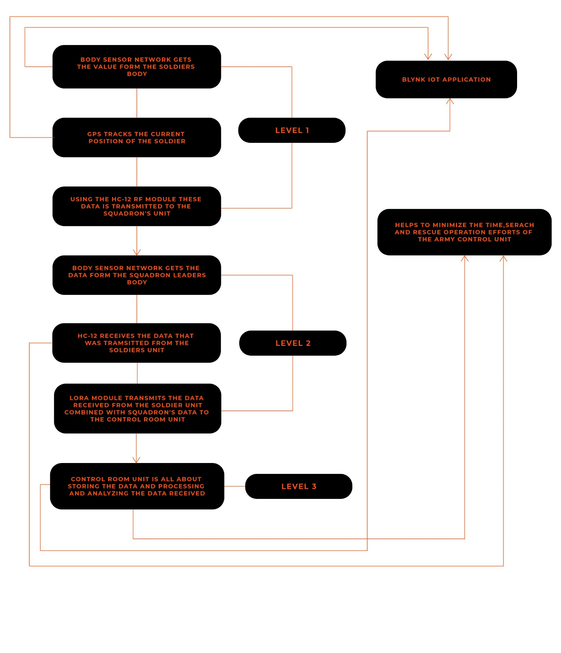

The block diagram below explains how the nodes and all the internal sensors are connected.

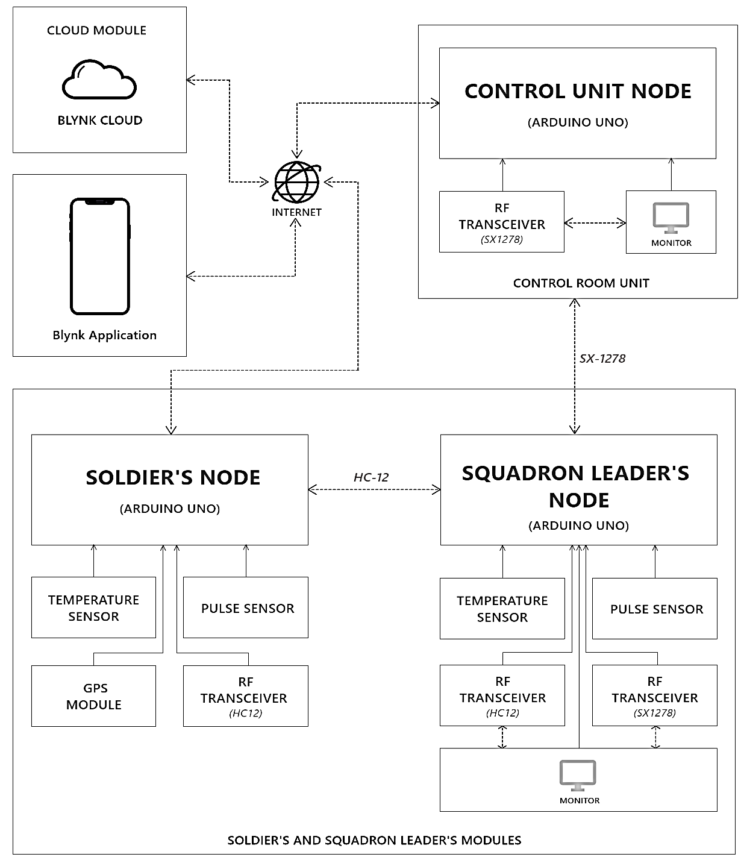

Circuit Diagram of Project:
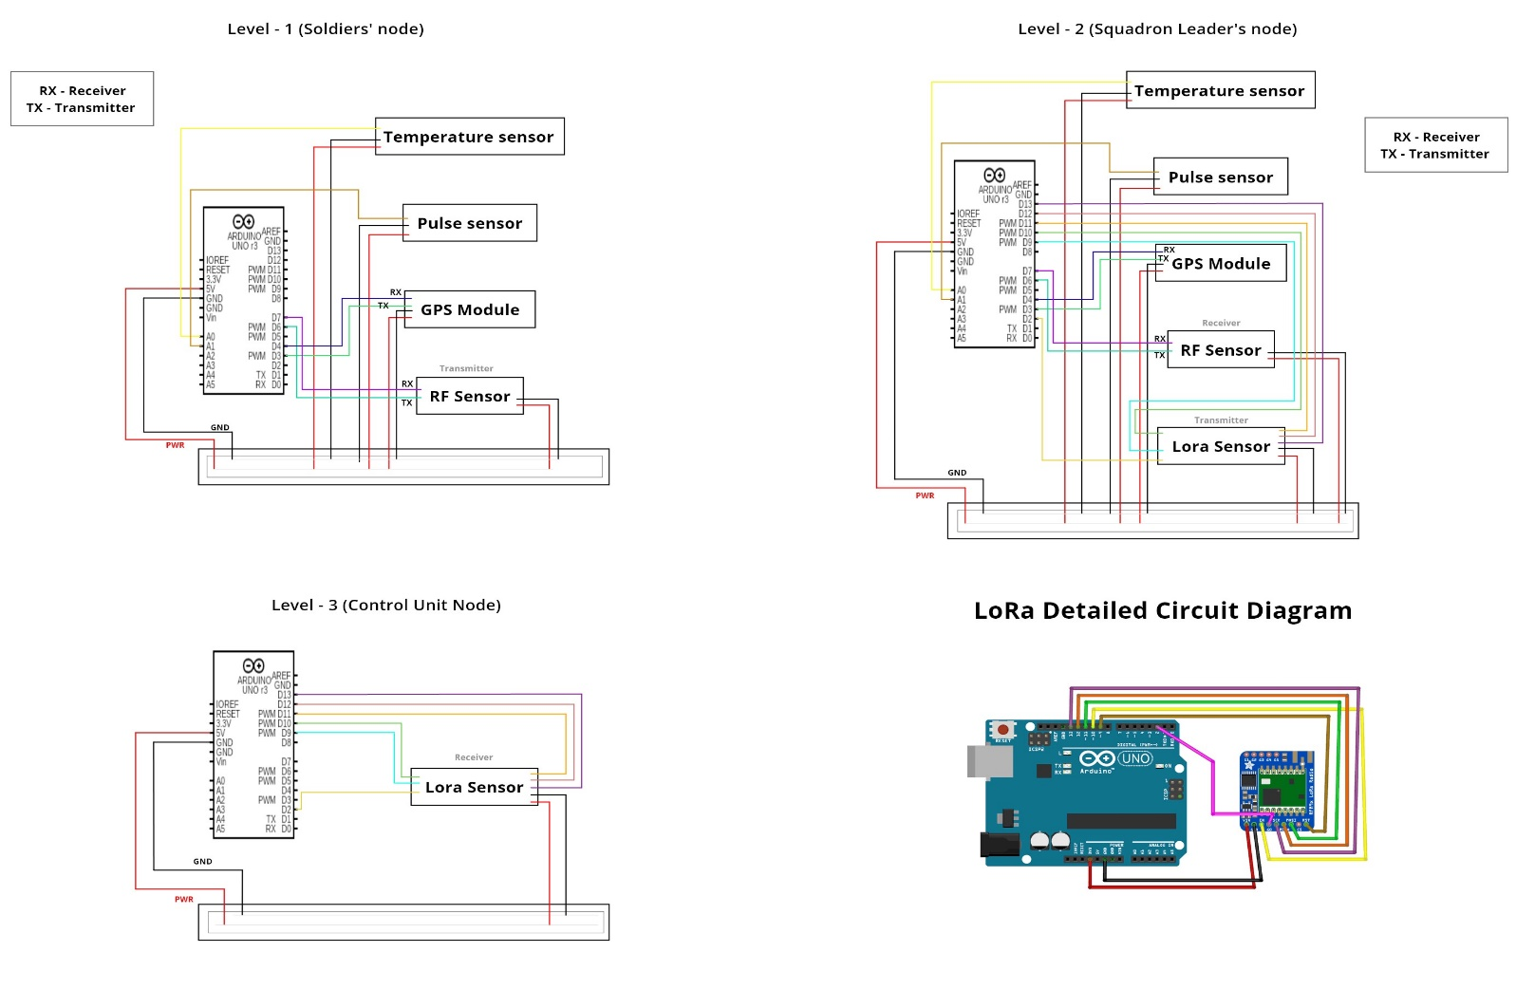
APPLICATIONS

APPLICATIONS:

1. Defence Forces

The project can be implemented in battle field or high altitude areas where health and location of soldiers is the most basic information which should be known to the control room.

2. Civilians

This project can also be utilized by individuals who work in remote areas or high altitudes wherein the most basic information should be known to someone dear to them or their guardian’s.

PROJECT TIMELINE

1. PHASE 1st

We will make feasible Definition about project objectives, scope, and deliverables. Then identify key stakeholders and project team members. Establish communication channels and project management tool Conduct meetings with military healthcare professionals and soldiers to gather system requirements. After that we define the specific health parameters to be monitored, Identify desired machine learning features and capabilities. Design the architecture of the smart health monitoring system. Then Select machine learning algorithms for health data analysis. Specify hardware and sensor requirements. Integrate wearable sensors and devices for health data collection. Implement secure communication protocols between sensors and the data collection module. Doing above we begin collecting sample data for machine learning model training.

2. PHASE 2nd

In the phase we will develop and train machine learning models for health parameter analysis. Test and refine the models using collected data and Evaluate model accuracy and performance. After we Choose and integrate a cloud computing platform for data storage and processing. Implement data transmission protocols between sensors and the cloud. Set up a secure and scalable cloud infrastructure. Then Design a user-friendly interface for soldiers and healthcare professionals. Implement real-time visualization of health data. To integrate machine learning insights into the user interface we conduct comprehensive system testing to identify and fix bugs. Then optimize the system for performance and responsiveness. As to Validate machine learning model accuracy and reliability.

3. PHASE 3rd

We Collect user feedback and address any issues or enhancement requests. Make iterative improvements to the system based on user experience. Conduct additional training sessions if necessary and Perform final testing and quality assurance checks. Ensure compliance with security and regulatory standards. Address any remaining issues before full deployment Deploy the smart health monitoring system for soldiers in operational settings. Monitor system performance and address any real-world challenges. Conduct final user training session

4. PHASE 4th

After completing the above steps here comes to the final step for establishing a system for monitoring and tracing soldiers health. Do and Implement regular updates, patches, and improvements. Address and counter any emerging issues or user feedback.

CONCLUSION AND FUTURE SCOPE

Soldier’s being an important part of our nation’s security, their health vitals and their location needs to be regularly monitored for their safety and their efficient working. Wireless communication with IoT makes the whole experience of monitoring soldiers health vitals and their location, smart efficient and fast. Technologies like IoT has fundamentally reformed the way we live and work, it has made our life easier.

Above proposed system not only monitors real-time health and location data of the soldiers but also provides necessary data to help us determine the last position and the health data of the soldiers if he gets lost, so as to track him down and send help.

This system increases the efficiency of the soldiers working in the field and also reduces the effort of search and rescue operation led by control room unit at the same time. All in all, the system being compact and less in weight makes it more ideal for the soldier’s and the squadron leaders to carry the system with them, which in turns helps the control unit node to monitor their data of in real-time, even if they are apart.

There is an enormous horizon of possibilities which could be offered - new designs, advanced system could be introduced to improve the conditions and efficiency of the system, and by introducing AI/ML algorithms we can predict out in near future if any soldier might require medical attention beforehand, other than this it can also predict whether a component or sensor might need attention or replacement. Other improvements that can be included is implementing advanced security protocols/techniques on the wireless RF modules so as to make the whole process of transmission and receiving sensors data more secure and reliable.

REFERENCE

[1] Hock Beng Lim, Di Ma, Bang Wang, Zbigniew Kalbarczyk, Ravishankar K. Iyer, Kenneth L. Watkin (2010) “A Soldier Health Monitoring System for Military Applications” International Conference on Body Sensor Networks, pp: (246-249).

[2] William Walker, A. L. Praveen Aroul, Dinesh Bhatia (2009) “Mobile Health Monitoring Systems” 31st Annual International Conference of the IEEE EMBS, Minneapolis, Minnesota, USA, pp: (5199-5202).

[3] M. Pranav Sailesh, C. Vimal Kumar, B. Cecil, B. M. Mangal Deep, P. Sivraj (2014) “Smart Soldier Assistance using WSN” International Conference on Embedded Systems - (ICES 2014), IEEE, pp: (244-249).

[4] P.S. Kurhe, S.S. Agrawal (2013) “Real Time Tracking and Health Monitoring System of Remote Soldier Using ARM 7”, International Journal of Engineering Trends and Technology, 4(3), pp: (311-315).

[5] Shruti Nikam, Supriya Patil, Prajkta Powar, V. S. Bendre (2013) “GPS Based Soldier Tracking and Health Indication System” International Journal of Advanced Research in Electrical, Electronics and Instrumentation Engineering, 2(3), pp: (1082-1088).

[6] Prof. Pravin Wararkar, Sawan Mahajan, Ashu Mahajan, Arijit Banerjee, Anchal Madankar, Ashish Sontakke (2013) “Soldier Tracking and Health Monitoring System” The International Journal of Computer Science & Applications, 2(02), pp: (81-86).

[7] Govindaraj A., Dr. S. Sindhuja Banu (2013) “GPS Based Soldier Tracking and Health Indication System with Environmental Analysis”, International Journal of Enhanced Research in Science Technology & Engineering, 2(12), pp: (46-52).

[8] Palve Pramod, “GPS Based Advanced Soldier Tracking With Emergency Messages & Communication System” (2014) International Journal of Advance Research in Computer Science and Management Studies, 2(6), pp: (25-32).

[9] Mr. Rajdeep Limbu, Prof. V. V. Kale (2014) “GPS Based Soldier Tracking and Health Monitoring System” International Journal for Technological Research in Engineering, 1(12), pp: (1485-1488).

[10] Rubina.A.Shaikh (2012) “Real Time Health Monitoring System of Remote Patient Using Arm7” International Journal of Instrumentation, Control and Automation, 1(3-4), pp: (102-105).

[11] Ekta Madhyan, Mahesh Kadam (2014) “A Unique Health Care Monitoring System Using Sensors and ZigBee Technology” International Journal of Advanced Research in Computer Science and Software Engineering, 4(6), pp: (501-509).

[12] Dr. S. S. Riaz Ahamed (2009) “The Role of ZigBee Technology in Future Data Communication System” Journal of Theoretical and Applied Information Technology, 5(2), pp: (129-135).

[13] Nisha Ashok Somani, Yash Patel (2012) “ZigBee: A Low Power Wireless Technology for Industrial Applications” International Journal of Control Theory and Computer Modeling, 2(3), pp: (27-33).

[14] P. Rohitha, P. Ranjeet Kumar, Prof. N. Adinarayana, Prof. T. Venkat Narayana Rao (2012) “Wireless Networking through ZigBee Technology” International Journal of Advanced Research in Computer Science and Software Engineering, 2(7) , pp: (49-54).

[15] Dineshkumar Jaiswar, Sanjna S. Repal (2015) “Real Time Tracking and Health Monitoring of Soldiers using ZigBee Technology: a Survey” International Journal of Innovative Research in Science, Engineering and Technology, 4(7).

[16] Shruti Nikam, Supriya Patil, Prajkta Powar, V.S.Bendre (2013) “GPS based Soldier Tracking and Health Indication System” International Journal of Advanced Research in Electrical, Electronics and Instrumentation Engineering, 2(3).

[17] Akshita V. Armarkar, Deepika J. Punekar, Mrunali V. Kapse, Sweta Kumari, Jayshree A. Shelke (2017) “Soldier Health and Position Tracking System” IJESC, 7(3).

[18] Afef Mdhaffar, Tarak Chaari, Kaouthar Larbi, Mohamed Jmaiel and Bernd Freisleben (2017) “IoT-based Health Monitoring via LoRaWAN” IEEE EUROCON.

[19] M.V.N.R. Pavan Kumar, Ghadge Rasika Vijay, Patil Vidya Adhikrao, Bobade Sonali Vijaykumar (2014) “Health Monitoring and Tracking of Soldier Using GPS” International Journal of Research in Advent Technology, 2(4).

[20] R. Archana, S. Indira (2013) “Soldier Monitoring and Health Indication System” International Journal of Science and Research (IJSR)

[21] Hock Beng Lim, Di Ma, Bang Wang, Zbigniew Kalbarczyk, Ravishankar K. Ayer, Kenneth L. Watkin (2010) “A Soldier Health Monitoring System for Military Applications” International Conference on Body Sensor Networks, pp: (246-249)

[22] William Walker, A. L. Praveen Aroul, Dinesh Bhatia (2009) “Mobile Health Monitoring Systems” 31st Annual International Conference of the IEEE EMBS, Minneapolis, Minnesota, USA, pp: (5199-5202).

[23] M. Parma Salish, C. Vimal Kumar, B. Cecil, B. M. Mangal Deep, P. Sivraj (2014) “Smart Soldier Assistance using WSN” International Conference on Embedded Systems - (ICES 2014), IEEE, pp: (244-249).

[24] P.S. Kruse, S.S. Agrawal (2013) “Real Time Tracking and Health Monitoring System of Remote Soldier Using ARM 7”, International Journal of Engineering Trends and Technology, 4(3), pp: (311-315).

[25] Shruti Nikam, Supriya Patil, Prajkta Powar, V. S. Bendre (2013) “GPS Based Soldier Tracking and Health Indication System” International Journal of Advanced Research in Electrical, Electronics and Instrumentation Engineering, 2(3), pp: (1082-1088)

[26] Prof. Pravin Wararkar, Sawan Mahajan, Ashu Mahajan, Arijit Banerjee, Anchal Madankar, Ashish Sontakke (2013) “Soldier Tracking and Health Monitoring System” The International Journal of Computer Science & Applications, 2(02), pp: (81-86)

[27] Govindaraj A., Dr. S. Sindhuja Banu (2013) “GPS Based Soldier Tracking and Health Indication System with Environmental Analysis”, International Journal of Enhanced Research in Science Technology & Engineering, 2(12), pp: (46-52).

